**Assignment Activity Unit 2**

**Introduction**

This project consists of two exercises that focus on creating an interactive travel blog using HTML, CSS, and JavaScript. The goal is to display different travel destinations and their attractions in an engaging and user-friendly way. Exercise A focuses on listing continents and cities, while Exercise B presents specific landmarks with images and descriptions. The use of CSS and JavaScript improves user experience by making the page interactive and visually appealing.

**Exercise A: Interactive Travel Destinations**

In Exercise A, we created a webpage that showcases different travel destinations categorized by continents. The user can navigate through the destinations by clicking on numbered buttons, each corresponding to a specific region: Europe, Asia, America, and Africa. The structure is based on HTML elements such as headings (<h1>, <h2>), lists (<ol>, <ul>), and anchor tags (<a>). The id attribute is used to link each button to its respective destination section.

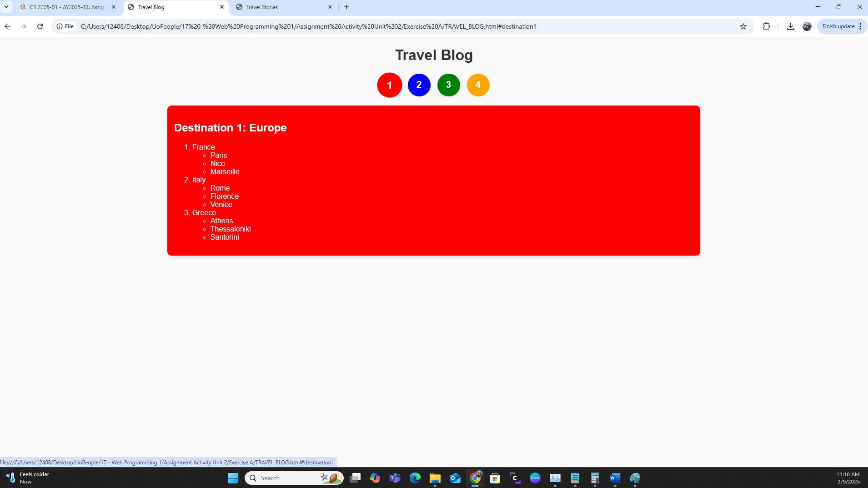

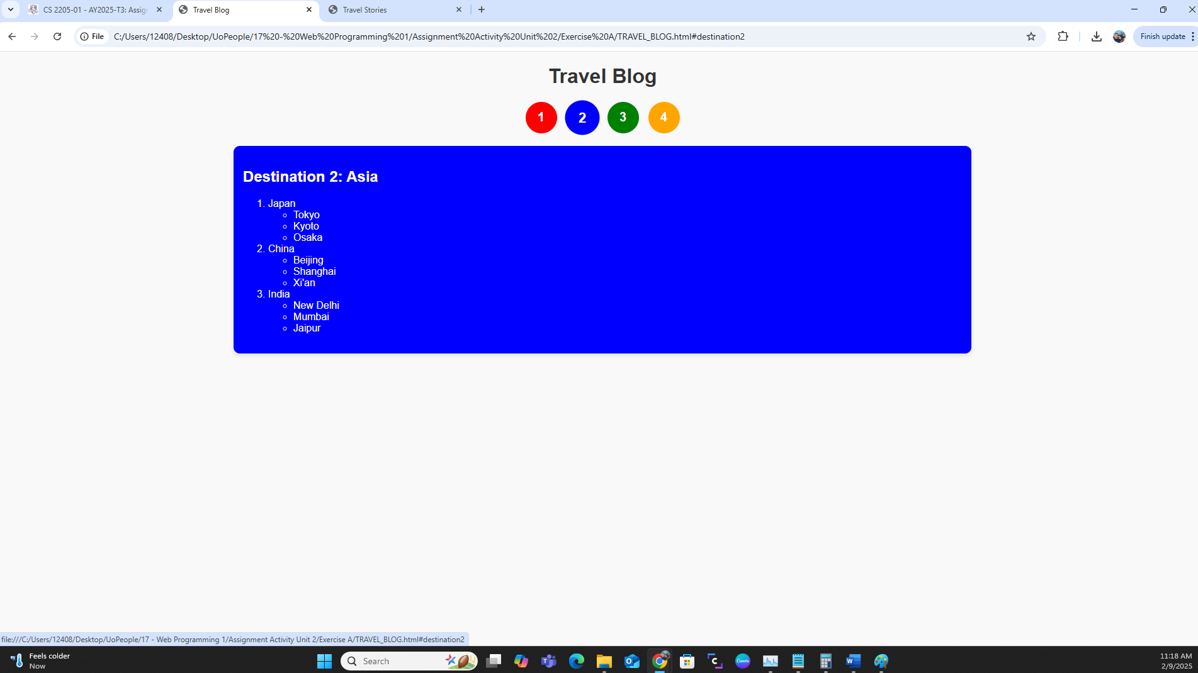

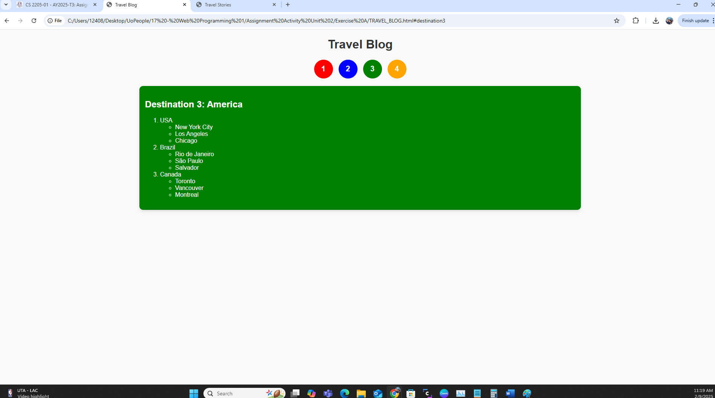

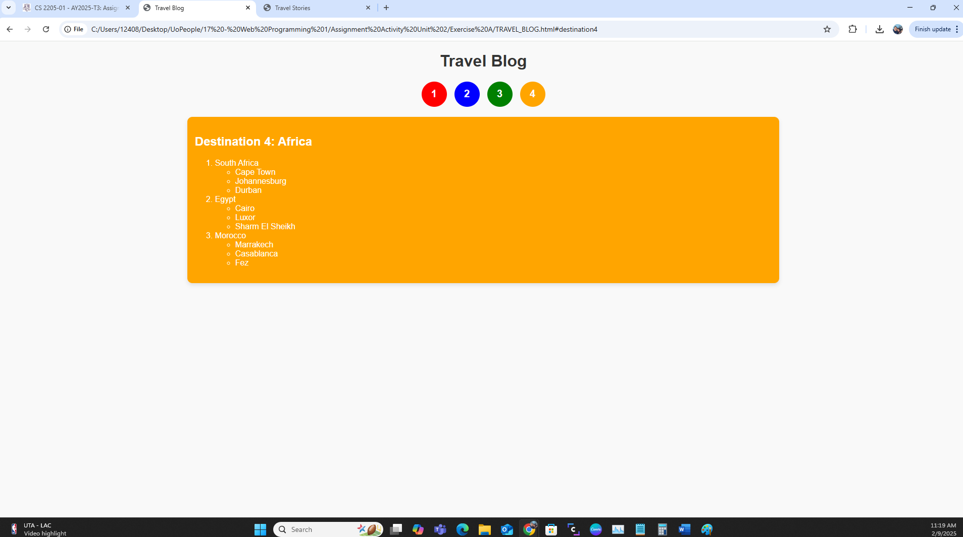

**CSS Design**

CSS plays a crucial role in styling the page and making it visually appealing. Some of the key styling elements include:

* **Background Color:** Each destination has a unique background color that changes when selected. For example, Europe has a red background, while Asia has blue.
* **Navigation Buttons:** The numbered buttons use CSS properties such as border-radius for a circular shape and transform: scale(1.1) for a hover effect.
* **List Styling:** The text color of the lists changes to white when a destination is selected, ensuring readability against the colored backgrounds.

**Interactivity**

This part of the project utilizes the :target pseudo-class in CSS to dynamically display a selected destination. When a user clicks on a number, the corresponding section appears while the others remain hidden. This is an efficient way to create interactive content without requiring JavaScript.

**Complete code, exercise A:**

**html:**

<!DOCTYPE html>

<html lang="en">

<head>

<meta charset="UTF-8">

<meta name="viewport" content="width=device-width, initial-scale=1.0">

<title>Travel Blog</title>

<link rel="stylesheet" href="stylesA.css">

</head>

<body>

<h1>Travel Blog</h1>

<div class="number-container">

<a href="#destination1" class="number one">1</a>

<a href="#destination2" class="number two">2</a>

<a href="#destination3" class="number three">3</a>

<a href="#destination4" class="number four">4</a>

</div>

<div id="destination1" class="destination">

<h2>Destination 1: Europe</h2>

<ol>

<li>France

<ul>

<li>Paris</li>

<li>Nice</li>

<li>Marseille</li>

</ul>

</li>

<li>Italy

<ul>

<li>Rome</li>

<li>Florence</li>

<li>Venice</li>

</ul>

</li>

<li>Greece

<ul>

<li>Athens</li>

<li>Thessaloniki</li>

<li>Santorini</li>

</ul>

</li>

</ol>

</div>

<div id="destination2" class="destination">

<h2>Destination 2: Asia</h2>

<ol>

<li>Japan

<ul>

<li>Tokyo</li>

<li>Kyoto</li>

<li>Osaka</li>

</ul>

</li>

<li>China

<ul>

<li>Beijing</li>

<li>Shanghai</li>

<li>Xi'an</li>

</ul>

</li>

<li>India

<ul>

<li>New Delhi</li>

<li>Mumbai</li>

<li>Jaipur</li>

</ul>

</li>

</ol>

</div>

<div id="destination3" class="destination">

<h2>Destination 3: America</h2>

<ol>

<li>USA

<ul>

<li>New York City</li>

<li>Los Angeles</li>

<li>Chicago</li>

</ul>

</li>

<li>Brazil

<ul>

<li>Rio de Janeiro</li>

<li>São Paulo</li>

<li>Salvador</li>

</ul>

</li>

<li>Canada

<ul>

<li>Toronto</li>

<li>Vancouver</li>

<li>Montreal</li>

</ul>

</li>

</ol>

</div>

<div id="destination4" class="destination">

<h2>Destination 4: Africa</h2>

<ol>

<li>South Africa

<ul>

<li>Cape Town</li>

<li>Johannesburg</li>

<li>Durban</li>

</ul>

</li>

<li>Egypt

<ul>

<li>Cairo</li>

<li>Luxor</li>

<li>Sharm El Sheikh</li>

</ul>

</li>

<li>Morocco

<ul>

<li>Marrakech</li>

<li>Casablanca</li>

<li>Fez</li>

</ul>

</li>

</ol>

</div>

</body>

</html>

**css:**

body {

font-family: Arial, sans-serif;

text-align: center;

background-color: #f9f9f9;

}

h1 {

color: #333;

}

.number-container {

display: flex;

justify-content: center;

gap: 15px;

margin-top: 20px;

}

.number {

width: 50px;

height: 50px;

display: flex;

align-items: center;

justify-content: center;

color: white;

font-size: 20px;

font-weight: bold;

border-radius: 50%;

cursor: pointer;

text-decoration: none;

transition: transform 0.2s ease-in-out;

}

.number:hover {

transform: scale(1.1);

}

/* Number colors */

.one { background-color: red; }

.two { background-color: blue; }

.three { background-color: green; }

.four { background-color: orange; }

/* Destination container */

.destination {

display: none;

text-align: left;

width: 60%;

margin: 20px auto;

padding: 15px;

background-color: white;

box-shadow: 0px 4px 8px rgba(0, 0, 0, 0.1);

border-radius: 10px;

}

/* Background color change when destination is selected */

#destination1:target {

display: block;

background-color: red;

color: white;

}

#destination2:target {

display: block;

background-color: blue;

color: white;

}

#destination3:target {

display: block;

background-color: green;

color: white;

}

#destination4:target {

display: block;

background-color: orange;

color: white;

}

/* Ensure list text remains white */

.destination:target h2,

.destination:target ol,

.destination:target ul,

.destination:target li {

color: white;

}

**Exercise B: Travel Stories with Images**

Exercise B expands on the travel blog by introducing a table that displays famous landmarks in different cities. Each row contains the name of the city and an image of a popular tourist attraction. Clicking on an image reveals more details about the attraction.

**HTML Table Structure**

The table is structured with:

* A <th> row that defines the headers: "Destination" and "Attraction."
* <td> elements that contain city names and images.
* <a> tags wrapped around images to make them clickable.

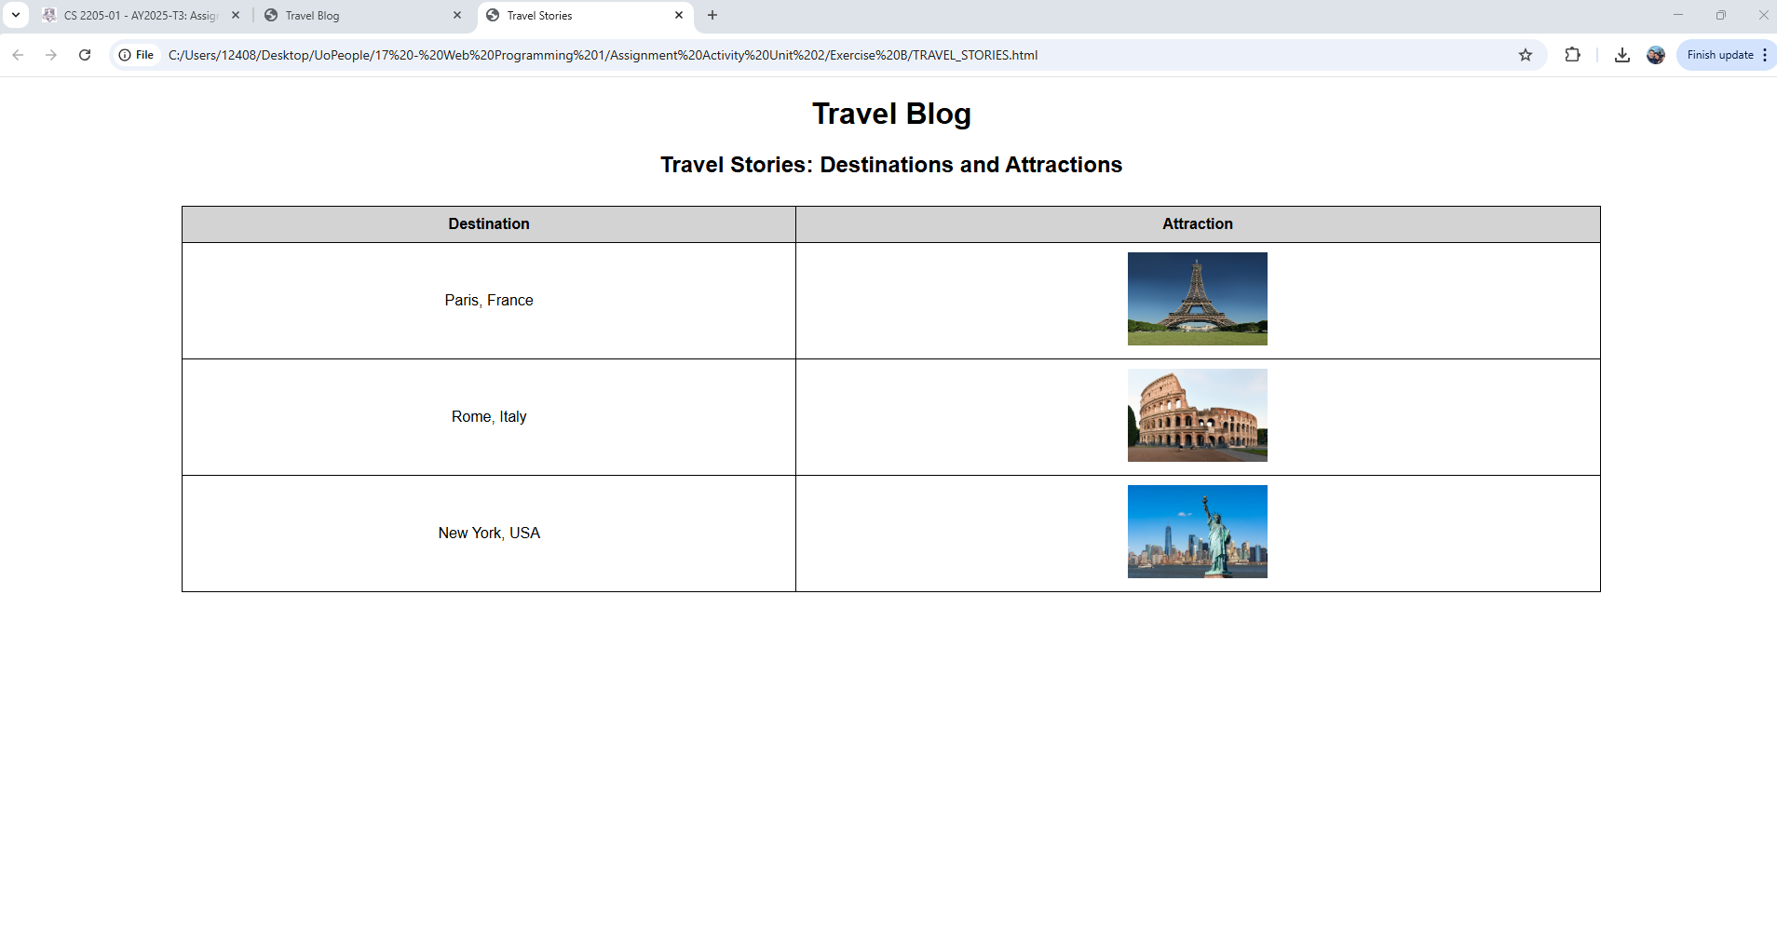

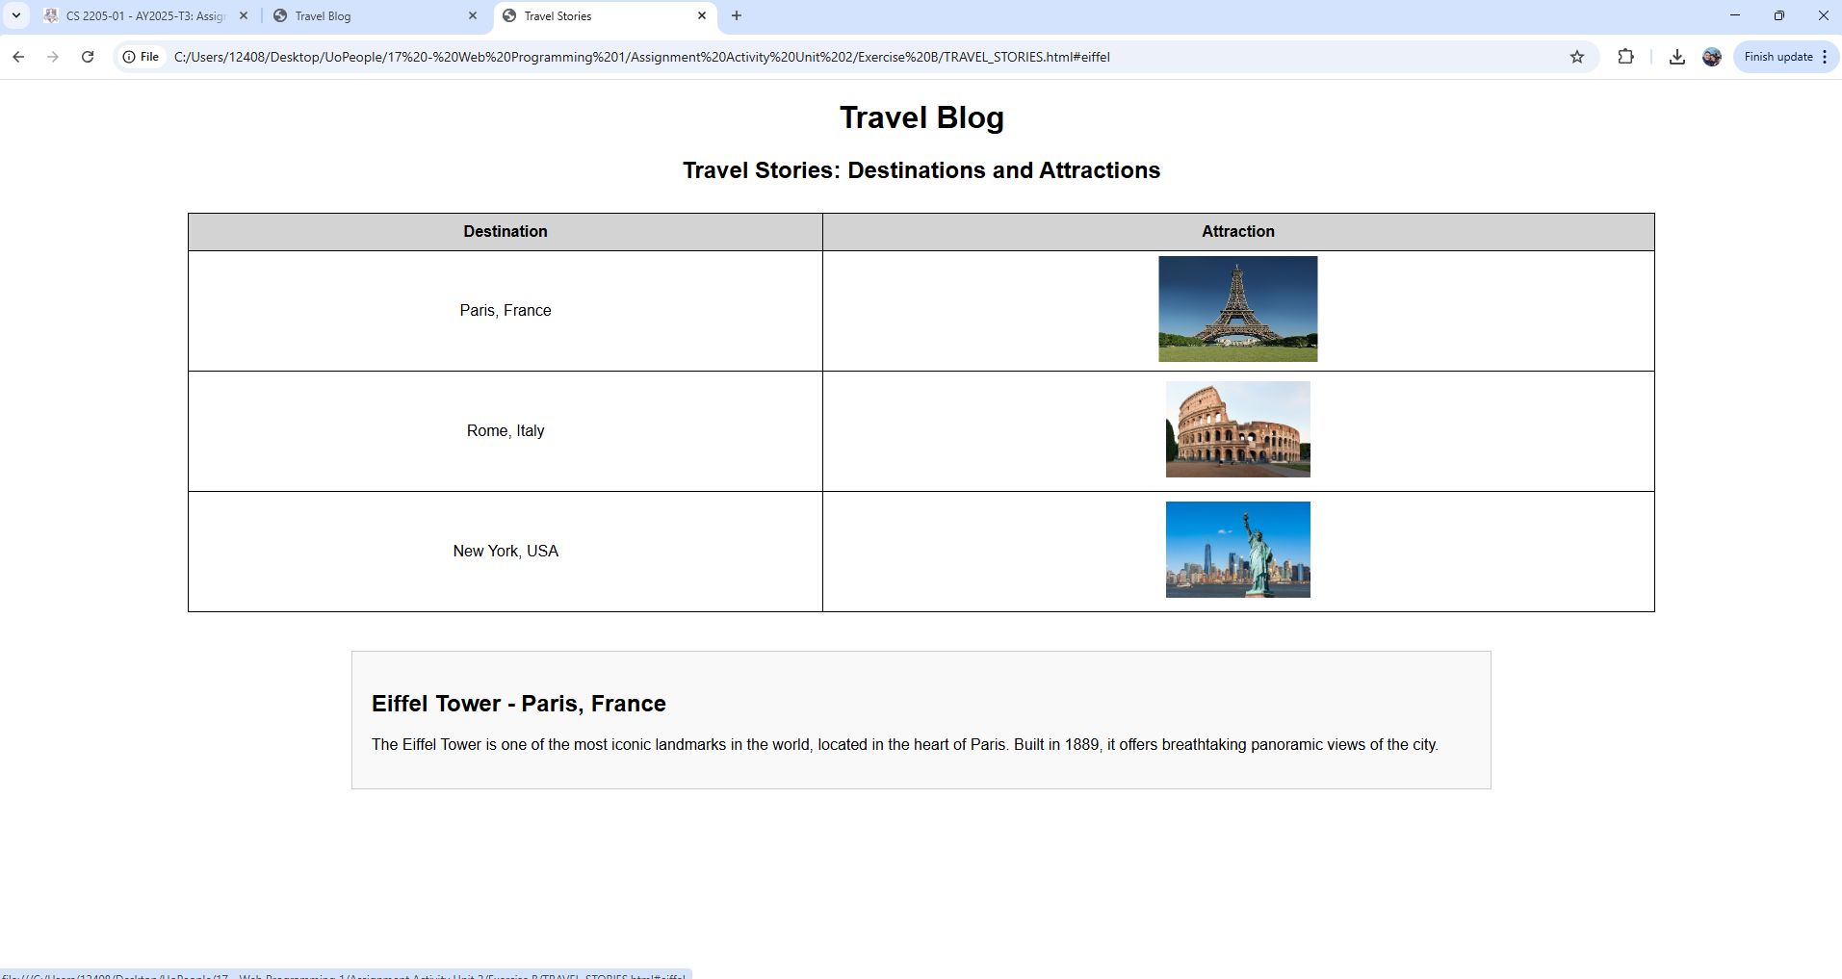

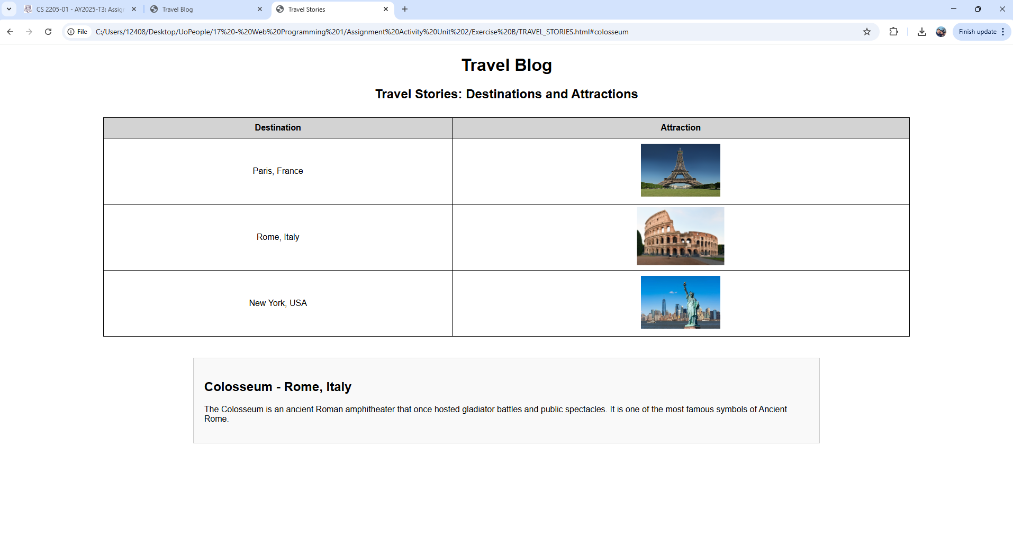

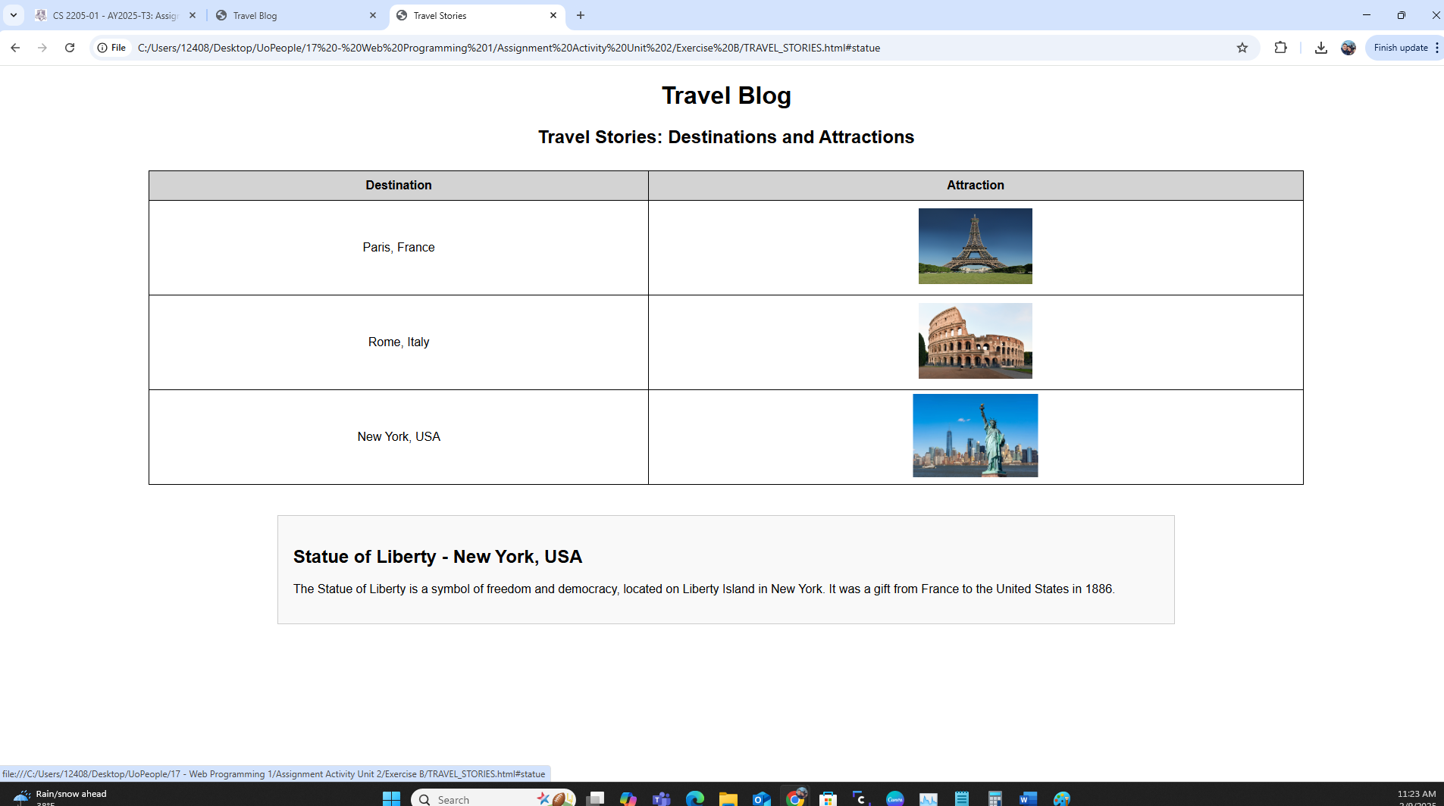

**JavaScript Functionality**

Unlike Exercise A, this section requires JavaScript for interactivity. The function showAttraction(id) is triggered when a user clicks on an image. It:

1. Hides all attraction descriptions by setting their display property to "none."
2. Displays the corresponding attraction section by changing its display property to "block."

Using JavaScript allows the page to update dynamically without refreshing, improving user experience.

**CSS Styling**

* **Table Design:** The table is centered, and borders are applied to each cell for clarity.
* **Image Effects:** Images have a hover effect (transform: scale(1.1)) to make them visually engaging.
* **Attraction Sections:** Each description is initially hidden and only appears when the corresponding image is clicked.

**Learning Outcomes**

This project helped in understanding fundamental web development concepts:

1. **HTML Structure:** The importance of semantic HTML for organizing content.
2. **CSS Styling:** Using colors, hover effects, and layout techniques to enhance design.
3. **Interactivity with CSS and JavaScript:** Learning how :target can control visibility in CSS and how JavaScript functions manipulate HTML elements dynamically.
4. **Usability Considerations:** Ensuring the webpage is user-friendly and visually appealing.

**Complete code, exercise B:**

html:

<!DOCTYPE html>

<html lang="en">

<head>

<meta charset="UTF-8">

<meta name="viewport" content="width=device-width, initial-scale=1.0">

<title>Travel Stories</title>

<link rel="stylesheet" href="stylesB.css">

</head>

<body>

<h1>Travel Blog</h1>

<h2>Travel Stories: Destinations and Attractions</h2>

<!-- Table with Travel Destinations and Attractions -->

<table>

<tr>

<th>Destination</th>

<th>Attraction</th>

</tr>

<tr>

<td>Paris, France</td>

<td>

<a href="#eiffel" onclick="showAttraction('eiffel')">

<img src="https://upload.wikimedia.org/wikipedia/commons/a/a8/Tour_Eiffel_Wikimedia_Commons.jpg" alt="Eiffel Tower">

</a>

</td>

</tr>

<tr>

<td>Rome, Italy</td>

<td>

<a href="#colosseum" onclick="showAttraction('colosseum')">

<img src="https://upload.wikimedia.org/wikipedia/commons/d/de/Colosseo_2020.jpg" alt="Colosseum">

</a>

</td>

</tr>

<tr>

<td>New York, USA</td>

<td>

<a href="#statue" onclick="showAttraction('statue')">

<img src="https://www.worldatlas.com/r/w1300/upload/f4/d8/7b/shutterstock-1397031029.jpg" alt="Statue of Liberty">

</a>

</td>

</tr>

</table>

<!-- Attraction Sections -->

<div id="eiffel" class="attraction-info">

<h2>Eiffel Tower - Paris, France</h2>

<p>The Eiffel Tower is one of the most iconic landmarks in the world, located in the heart of Paris. Built in 1889, it offers breathtaking panoramic views of the city.</p>

</div>

<div id="colosseum" class="attraction-info">

<h2>Colosseum - Rome, Italy</h2>

<p>The Colosseum is an ancient Roman amphitheater that once hosted gladiator battles and public spectacles. It is one of the most famous symbols of Ancient Rome.</p>

</div>

<div id="statue" class="attraction-info">

<h2>Statue of Liberty - New York, USA</h2>

<p>The Statue of Liberty is a symbol of freedom and democracy, located on Liberty Island in New York. It was a gift from France to the United States in 1886.</p>

</div>

<script>

function showAttraction(id) {

// Hide all attraction sections

let attractions = document.querySelectorAll(".attraction-info");

attractions.forEach(attraction => attraction.style.display = "none");

// Show the selected attraction

document.getElementById(id).style.display = "block";

}

</script>

</body>

</html>

**css:**

body {

font-family: Arial, sans-serif;

text-align: center;

}

/* Table Styling */

table {

width: 80%;

margin: 30px auto;

border-collapse: collapse;

}

th, td {

border: 1px solid black;

padding: 10px;

text-align: center;

}

th {

background-color: lightgray;

}

/* Image Styling */

img {

width: 150px;

height: 100px;

cursor: pointer;

transition: 0.3s;

}

img:hover {

transform: scale(1.1);

}

/* Attraction Sections */

.attraction-info {

display: none;

margin: 40px auto;

width: 60%;

text-align: left;

padding: 20px;

border: 1px solid #ccc;

background-color: #f9f9f9;

}

**Conclusion**

The Travel Blog Project demonstrates how to build an interactive and well-structured webpage using HTML, CSS, and JavaScript. Exercise A introduced the use of the :target pseudo-class for navigation, while Exercise B implemented JavaScript to display information dynamically. Both exercises emphasize clean design, responsive interaction, and a user-friendly experience. These skills are essential for web development and can be applied to various types of projects beyond travel blogs.

**References**

Feldman, L. (2019). *HTML and CSS: Design and Build Websites.* John Wiley & Sons. Duckett, J. (2014). *JavaScript and JQuery: Interactive Front-End Web Development.* John Wiley & Sons.